Welcome!
Date
Name
Spouse
Address
City
State Zip _________
Email

Please Contact By
❑ Card  Phone  Visit

Telephone Best Time to Call
Home ______________
Work ______________

Guest: First Time Second Time
Are you a church member: yes no
Church
City, State

Circle Appropriate Age/Grade Group(s)
Preschool: Ages: B-1 2-3 4-5
Children: Grades: K 1 2 3 4 5 6
Youth: Grades: 7 8 9 10 11 12
Adults: Ages:18-29 30s 40s 50s 60s+

How did you learn about our church?
Newspaper Friend Yellow Pages Mail
Other

I am a guest of:

New in the Community? Yes No
Names & ages of children at home

Weekly Service & Activity Schedule
April 6, 2014
9:45 a.m. Sunday School
11 a.m. Morning Worship
12:00-1:30 Kids in Action

6 p.m. Evening Service

Week of April 7 - 12
Wednesday, 6:30 p.m. Youth Activities
Wednesday, 6:45 p.m. Adult Prayer & Bible Study
Wednesday, 7:30 p.m. Praise Team Rehearsal
Thursday, 10 am Adult Fellowship
Saturday, 9:30 am Community Easter Egg Hunt

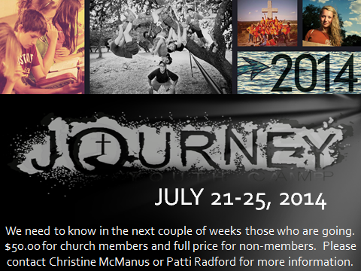

Upcoming Events
April
13 Business Meeting
18 Good Friday
20 Easter Sunday
24 Adult Fellowship – 10 am
27 Musicians and Church Staff Appreciation Day

Birthday & Anniversary Recognitions will occur on the final Sunday of each month.

Graduation Banquet - If you graduated in December, or will graduate in June 2014, please let Geneva Davis or Otisann McManus know so you can be recognized at the upcoming Graduation Banquet.

Knobbs Springs Baptist Church

And he said to them, "I have eagerly desired to eat this Passover
with you before I suffer. For I tell you, I will not eat it again
until it finds fulfillment in the kingdom of God." After taking the cup,
he gave thanks and said, "Take this and divide it among you.
For I tell you I will not drink again of the fruit of the vine until the
kingdom of God comes." And he took bread, gave thanks
and broke it, and gave it to them, saying, "This is my body
given for you; do this in remembrance of me." In the same way,
after the supper he took the cup, saying, "This cup is the new
covenant in my blood, which is poured out for you. But the hand of
him who is going to betray me is with mine on the table.
The Son of Man will go as it has been decreed, but woe to that man
who betrays him." They began to question among themselves
which of them it might be who would do this. Also a dispute arose
among them as to which of them was considered to be greatest.
Jesus said to them, "The kings of the Gentiles lord it over them; and
those who exercise authority over them call themselves Benefactors.
But you are not to be like that. Instead, the greatest among you
should be like the youngest, and the one who rules like the one
who serves. For who is greater, the one who is at the table or
the one who serves? Is it not the one who is at the table?
But I am among you as one who serves. You are those who have
stood by me in my trials. And I confer on you a kingdom, just as
my Father conferred one on me, so that you may eat and drink
at my table in my kingdom and sit on thrones,
judging the twelve tribes of Israel.
Luke 22:15-30

April 6, 2014

Church Information:

KnobbsSpringsBC.com KnobbsSpringsBaptist@gmail.com
1662 CR 305, McDade, Texas 78650 512-273-2743
Brother Dwight Reagan 512-247-6448
Kimberly Tabor, Office Manager 512-698-2804

